Running Project

* + Under coding folder files placed in git hub should be placed (. idea ,Admin, bi_objective_Hyper_Herustic, users,assets,manage.py,requirements.bat)
  + Under database folder(bi.sql) should be placed)
  + Under datasets folder (binew.csv must be placed)
  + After placing files told as above Install Below
  + 
  + 
  + Note: Uninstall latest Python version on you PC
    - 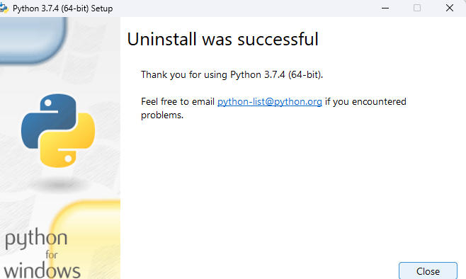
  + Open XAMPP
  + 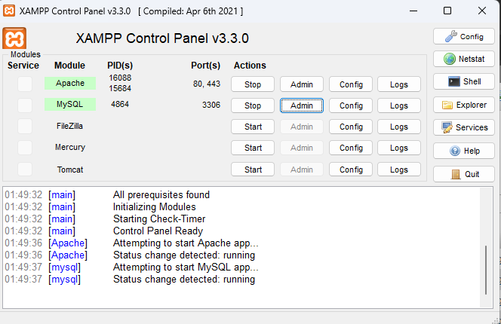
  + Open Admin of MySQL and Import Database
  + 



* + Browse database (from database folder of project file)
  + 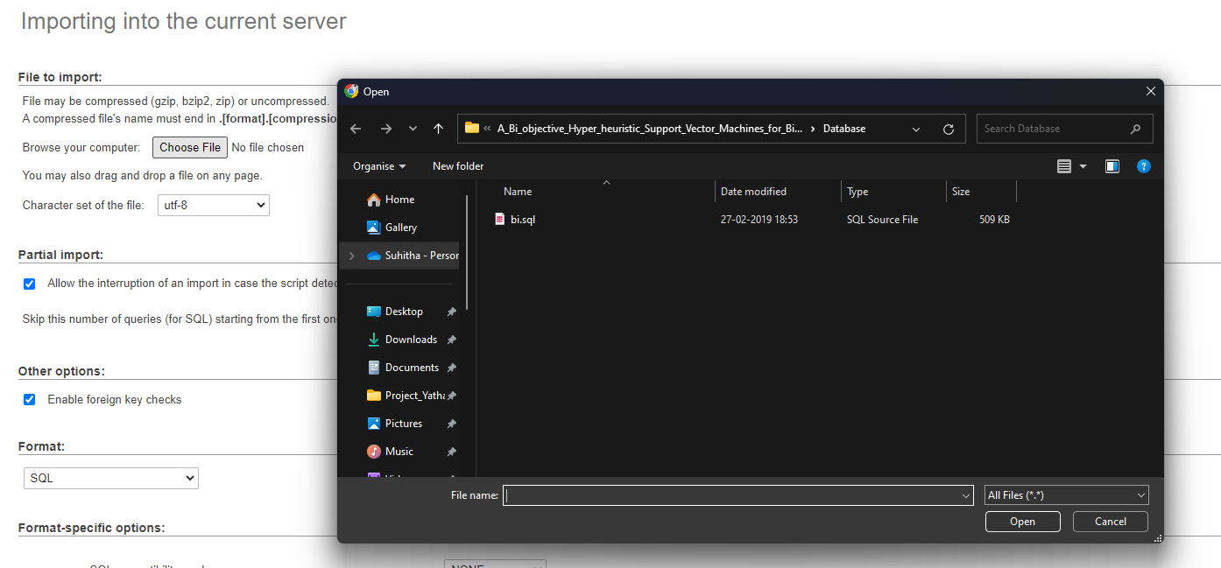
  + Click on “GO”
  + Open requirements.bat with admin (which is inside coding file)
  + 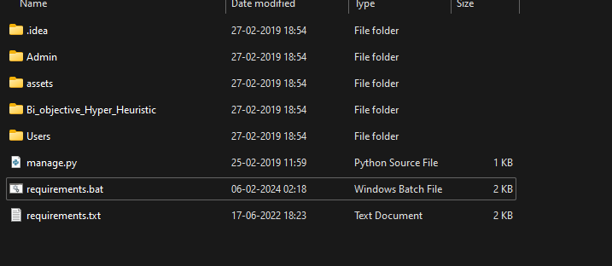
  + 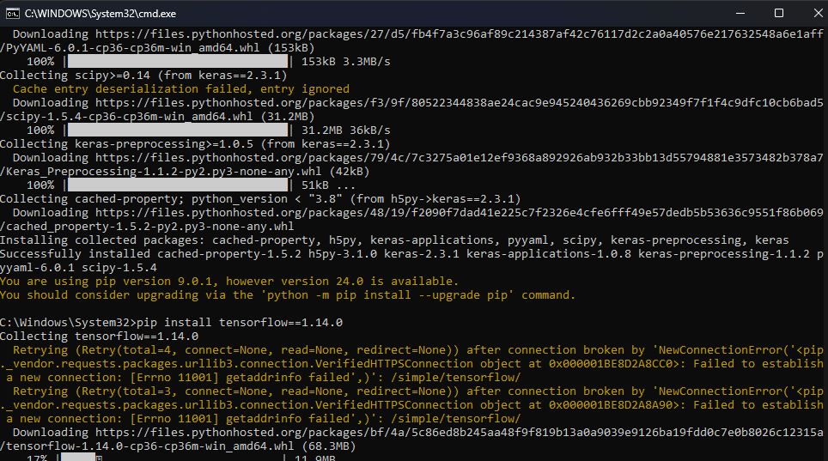
  + After Installtion of all the requiremnets
  + In the folder(coding) type “ python manage.py runserver”(in command prompt)
  + And goto any browser and open “ <http://127.0.0.1:8000/>” (this link is given after above command is executed)